**WALCHAND COLLEGE OF ENGINEERING**

**SANGLI**

(An Autonomous Institute)



A Mini-Project Report on

**Smart Dustbin**

Submitted By

1. Ashish Kore 2016BTEIT00065
2. Mohit Gholake 2016BTEIT00066
3. Aditya Kole 2016BTEIT00070

**Ms. B. S. Shetty Dr. S. P. Sonavane**

**(Project Guide) (HOD)**

Department of Information Technology

Third Year B.Tech.

2018-2019

**CERTIFICATE**

This is to certify that project report entitled as “Smart Dustbin”.

Submitted by-

1. Ashish Kore 2016BTEIT00065
2. Mohit Gholake 2016BTEIT00066
3. Aditya Kole 2016BTEIT00070

Has undergone a Mini Project work and successfully completed in the academic year 2018-2019 (SEM-II).

Date:15/05/2019 Ms. B. S. Shetty

Place: Sangli. (Project Guide)

**ACKNOWLEDGEMENT**

We are rather infused by the kind guidance of Ms. B. S. Shetty who put in the cradle of our Engineering studies and evaluated us to this end and mean of our project. We could not have been able to complete the project without the valuable guidance of the Respected Panel. Class Teachers Mr. M.B. Narnaware and Mr. A.A. Urunkar gave their valuable guidance, experience and time to make the project a success. Without the guidance of all these respected members, we are sure to be orphans in the vast ocean of Internet of Things. In the end, we would like to express a sincere thanks to all the people who helped us in the project completion directly or indirectly and feel lucky to have got their help.

**Table of Contents**

|  |  |  |  |  |  |  |  |  |  |  |  |  |  |  |  |  |  |  |  |  |  |  |  |  |  |  |  |  |  |
| --- | --- | --- | --- | --- | --- | --- | --- | --- | --- | --- | --- | --- | --- | --- | --- | --- | --- | --- | --- | --- | --- | --- | --- | --- | --- | --- | --- | --- | --- |
| |  |  |  | | --- | --- | --- | | **Sr. No** | **Contents** | **Page No.** | | 1. | Introduction | 1 | | 2. | Problem Statement | 1 | | 3. | Objectives | 2 | | 4. | Software and Specifications | 3-4 | | 5. | Implementation | 5-7 | | 6. | Significance of Project | 8 | | 7. | Future Work | 8 | | 8. | References | 8 | |  |  |

**1. INTRODUTION**

* 1. **Introduction**

In this Project, the idea of Internet of Things is used to lend smartness to a common object, Dustbin. The Sensors will sense the level of waste dumped into the dustbin. Once the threshold level is reached, a text message will be sent to the respective cleaner to collect the garbage for further unhampered use of the dustbin and avoid the overflow of public dustbins.

* 1. **BRIEF INTRODUCTION**

Municipal Waste Pick Up and Management is one of the critical functions and responsibilities of any Municipal Corporation across the country. The general awareness on hygiene and health has increased amongst citizens and the general public sees effective implementation of the regular pick up of Municipal Waste as a major factor in maintaining the respective town’s cleanliness and hygiene. Rapid increase in population, has led to improper waste management in metropolitan cities resulting in increased pests and spreading of diseases. But on the other hand, it is a major challenge to the corporation to ensure the pickup of the municipal waste from all the appointed locations of the town on a regular basis and dump it in the appointed yard.

1. **PROBLEM STATEMENT**

To create a system capable of alerting and monitoring the level of garbage in public garbage dustbin and ensuring timely collection of Waste.

1. **OBJECTIVES**
2. To give a technical solution to a social problem.
3. Create a prototype of Smart Dustbin for waste management.
4. Measure the dust level in the area using dust sensor.
5. Create android application for Smart Dustbin monitoring.

**4.SOFTWARE AND SPECIFICATIONS**

* **Software:**

1. Arduino IDE

2. C Programming

3. ThingSpeak Cloud

4. Android Application

* **Hardware:**

1. Arduino UNO

2. Ultrasonic Sensor

3. ESP8266 Wifi Module

4. Servo Motor

5. Power Supply

6. Bread Board

7. Jumper Wires

8. Dust Sensor

**5. IMPLEMENTATION**

1. This project is to design and build a prototype for a smart dustbin using Arduino.
2. It will have automatic lid opening mechanism by detecting person using ultrasonic sensor.
3. Using ultrasonic sensor it will detect level of garbage in dustbin and send data to ThingSpeak cloud.
4. We will fetch data from ThingSpeak cloud in android application and show level of garbage.
5. When garbage level is greater than threshold then it will send notification to concerned person.
6. Also when dust present in room cross the particular threshold it will send notification to the concern person

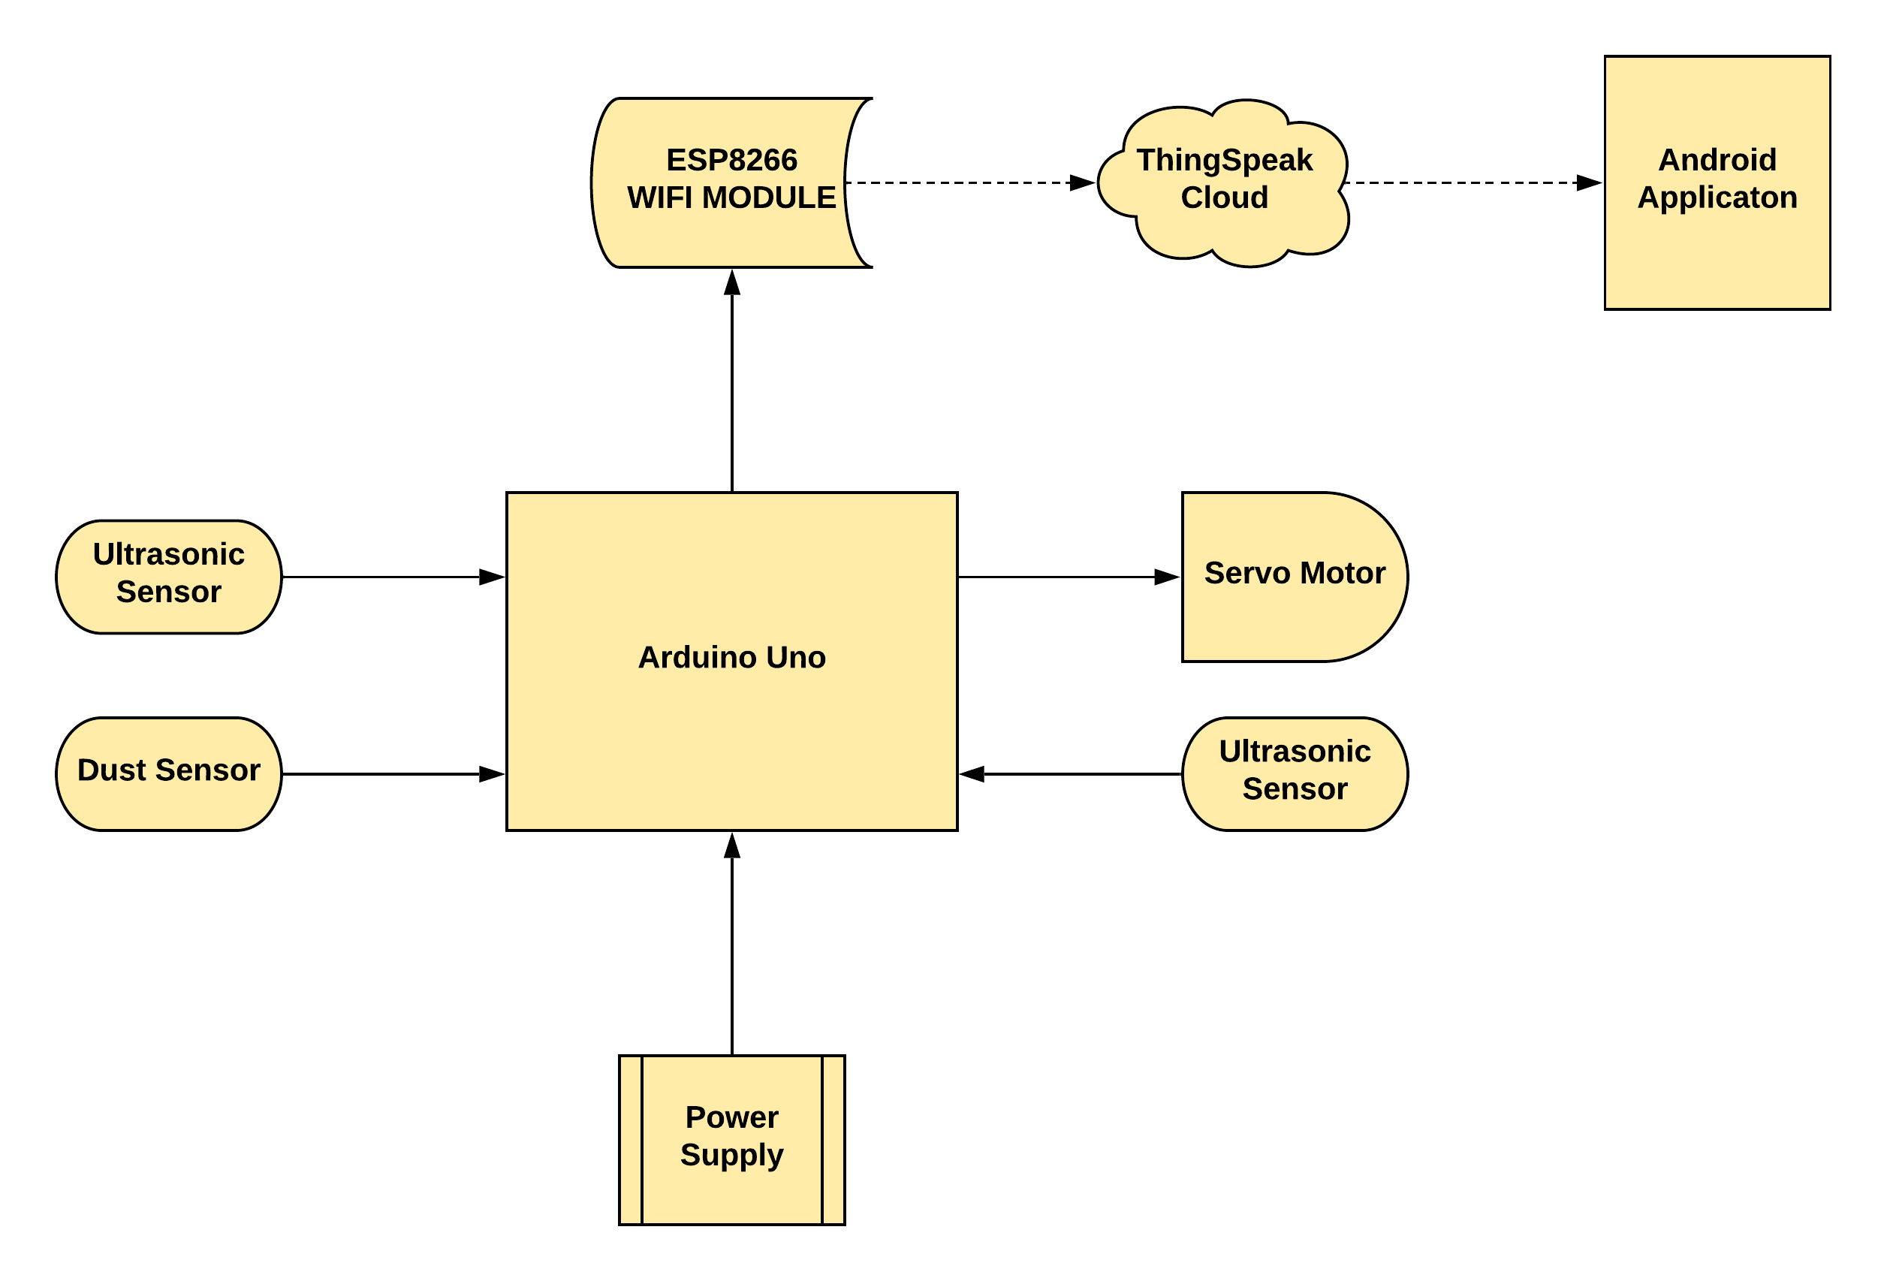

**Architecture Model**

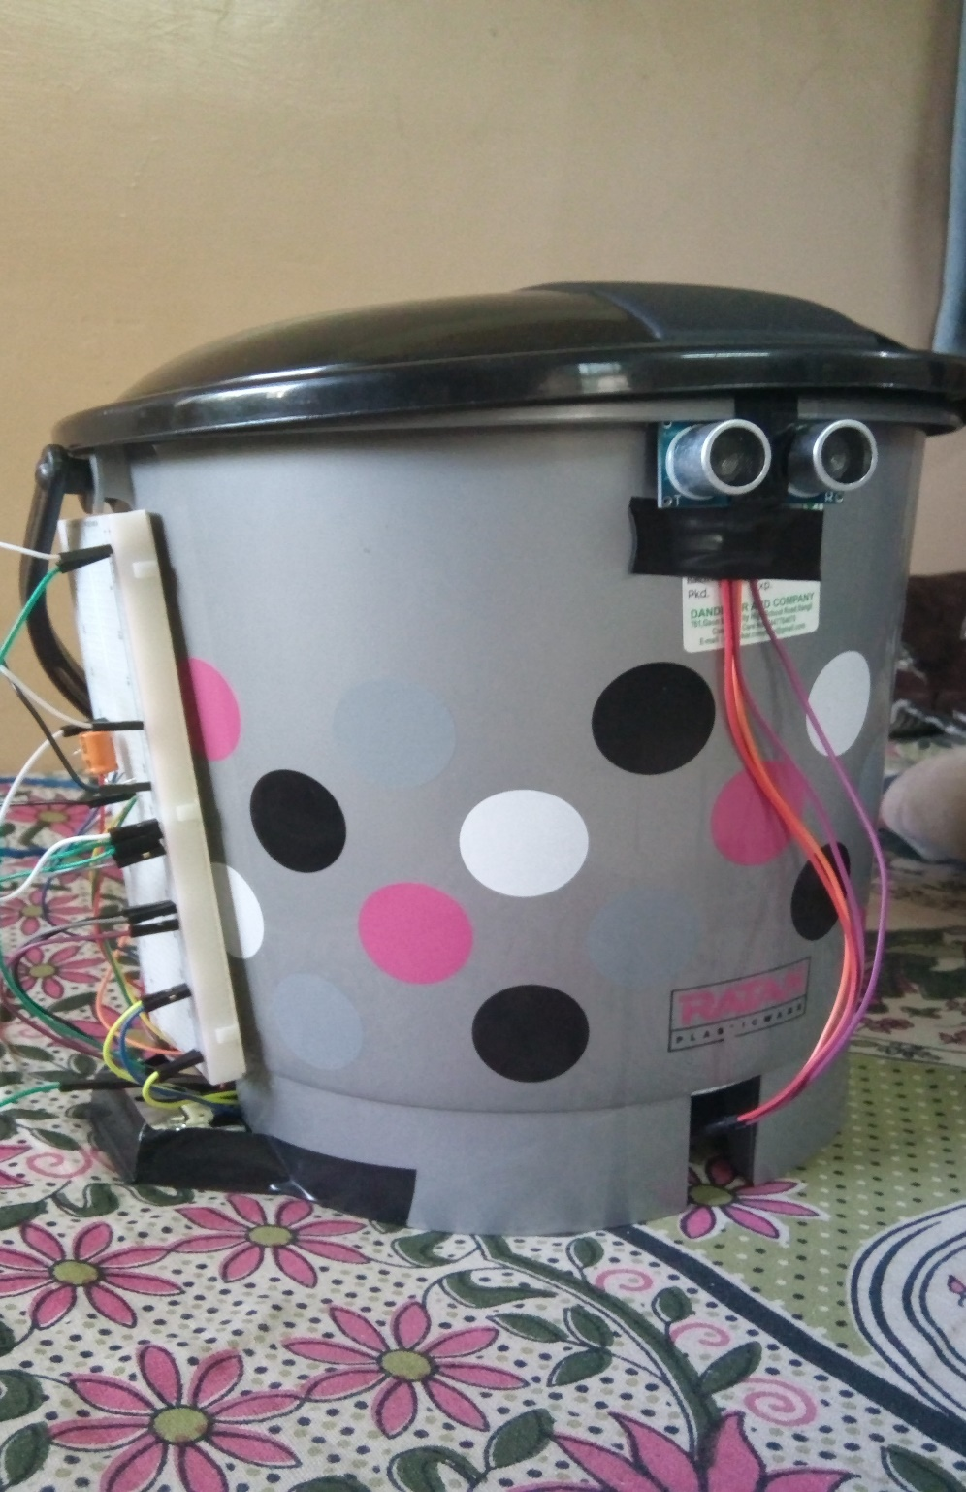

**Prototype Model**

**6. SIGNIFICANCE OF PROJECT**

1. Automatic lid opening

2. Garbage level detection

3. Dust level detection

4. Uploading data to ThinkSpeak cloud

5. Displaying the data in Android App

**7. FUTURE WORK**

1. Adding GPS system for dustbin location in smart city.

**8. REFERENCES**

1. <https://www.arduino.cc/en/Reference/ServoWrite>

2.<https://www.electronicshub.org/smart-dustbin-using-arduino/>

3. IoT Based Smart Garbage and Waste Collection Bin - S.S.Navghane, M.S.Killedar, Dr.V.M.Rohokale 3 .